A Report

On

**An Android Application and Cloud System For**

**Interactive Medical Diagnosis and Assistance**

Reported submitted in partial fulfillment of

Study Oriented Project (CS F266) / Lab Oriented Project (CS F367)

Done By

K Achyuth Reddy 2013A7PS041P

J Sai Krishna 2013A7PS141P

Vamsi Tadikonda 2013A7PS039P

C Raghu Vamsi 2013A7PS031P

T Sai Rohit 2013A7PS021P

L Satya Pavan 2013A7PS150P

Supervised by

Dr. Atanendu Sekhar Mandal

IC Design Group

CEERI Pilani

11 May,2016

**Birla Institute of Technology and Science**

**Pilani**

**Rajasthan-333031**

**Acknowledgement**

Our report will remain incomplete if we do not mention the efforts of those people who helped us in completing this project.

First of all we would like to thank Dr. Atanendu Sekhar Mandal, Scientist 'G', IC Design and Perception Engineering, for his continual guidance throughout the project, for encouraging and nurturing many brilliant insights into the project.

We would like to thank the CSIS Department, BITS-Pilani who gave us a chance to work in collaboration with CEERI. We would like to thank all the teachers who taught us all the concepts, enhanced our skills and made us work with this project. Last but not least we would like to thank our parents for supporting us in achieving our goals in academics.

**K Achyuth Reddy (2013A7PS041P)**

**J Sai Krishna (2013A7PS141P)**

**Vamsi Tadikonda (2013A7PS039P)**

**C Raghu Vamsi (2013A7PS031P)**

**T Sai Rohit (2013A7PS021P)**

**L Satya Pavan (2013A7PS150P)**

Contents

1. Abstract 4
2. Introduction 5
3. Previous Work 6
4. Multi Class 8
5. Android Interface 9
6. Cloud Processing 11
7. Conclusion 13
8. Scope for improvement 13
9. References 14
10. Test cases 15
11. **ABSTRACT**

With increasing population, and low medical support when compared to rise in population, especially in developing countries, there is a need to find good medical expertise in these conditions. This problem can be solved by developing an automated medical expert system which when given symptoms and conditions can diagnose a disease. Common diseases like seasonal viral fever, malaria, etc. are becoming more dangerous especially in rural areas where medical support is poor and reachability is less. In this paper, we focus on providing medical expertise for common diseases. Medical assistance app takes input as speech, processes the input, inquires for more details and gives final diagnosis. It also suggests the doctor who are experts on that particular field. Due this we can avoid having long queue in hospitals. Thus it is a simple redundant problem which can be tackled by making an interactive medical assistance app. The backend code runs on cloud to which the mobile app send requests for processing data. The paper also suggests some techniques which could be augmented to existing app.

1. **INTRODUCTION**

It is highly necessary to provide good medical facilities to people. To help countries cope with increase in population and common diseases, computer scientists are researching human interactive medical assistance models. Due to less number of experts in specific domain of medical diagnosis it is important to help doctors by assisting them in case frequently occurring diseases. Diagnosing malaria, typhoid, seasonal fevers and cold etc. using interactive medical systems helps doctors with the load of work. It could also play important role in rural areas where the medical facilities and reachability of medical experts is tough.

The paper explains a system which would help people from remote areas who have poor assistance from medical experts. In modern India, almost every person has an access to a mobile phone. Thus it could be easier to provide medical assistance through phone which would cost less and accessed easier. The system must take in symptoms as input through speech and should predict the disease with high error costs. The system could be deployed in cloud and could be accessed by anyone from any place of the world.

Having a medical assistance mobile application also helps to maintain health records of individuals which can be further used for extracting information. The first step of diagnosis process consists of patient describing his symptoms to doctor. In the next step doctor investigates about more symptoms and condition from the patient. This investigation process is a step by step questioning process. It also includes measuring blood pressure, temperature of body. The patient’s status can also be considered while diagnosing the disease. In the mobile app input taken through speech, converted to text, text is processed, keywords are identified and used for deciding most probable disease. The speech input is converted to text on mobile device and it is sent to the backend program residing in the cloud. This text is processed and the next question is sent to mobile device.

There are certain limitations such as we cannot measure temperature or blood pressure through a mobile device. The mobile app did not handle usage of patient’s history, diverse cases, rare diseases etc. The mobile application contains database for three diseases malaria, typhoid, and dengue. This knowledge base can be extended with diseases which are more common and have a consistent diagnosis process.

1. **PREVIOUS WORK**

Knowledge base in the project is built with the help of experts and medical textbooks. There will be symptom matrix for each disease. This matrix represents presence or absence of a particular symptom with respect to a particular disease.

Input is given as a transcript of patient’s condition and symptoms which is very similar to explaining to a real doctor. Then preprocessing of this obtained text is done. This is done using NLTK python library. Several techniques are used to process the input text such as sentenizing, tokenization, spell corrector, keyword extraction and stemming represented in order of their execution. Each of the above has different tasks. Sentenizing breaks the text into different sentences. Tokenization breaks the sentence into tokens. The spell corrector corrects them .then the keywords are extracted using removal of stop words and parsing the text using AIML (Artificial Intelligence Markup Language). These key words are stemmed using porter stemming algorithm.

Symptoms are obtained from the keyword with the use of database of symptoms. The disease matrix will be constructed with the help of above symptoms and their values in the knowledge base .After getting disease matrix with respect to a disease in knowledge base, for further analysis we need to get the mutual information between these two. With the help of mutual information theory, weights are provided to different situations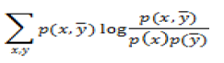

Where, X is represented as the disease and Y as the symptom

From this, we get the main symptom of the most probable disease. Then questions were asked to the patient depending up on the main symptoms obtained above and after each query, the disease matrix is updated. When there are no more further symptoms and all the analysis is done, the procedure is stopped and the most probable disease is obtained as output.

1. **MULTI CLASS**

The previous system had only 3 diseases namely typhoid, dengue and malaria. We tried to increase the number of diseases it can handle. We tried to implement diseases from various classes. We are currently handling fever class, digestion related and heart related diseases.

Fever related diseases: typhoid, malaria, and dengue.

Digestion related diseases: constipation and acid reflux.

Heart related diseases: Heart Attack.

We tried to implement only those diseases that have symptoms that a common man can detect without any equipment. For many of heart related diseases we cannot directly tell the symptoms because they need equipment for finding the heartbeat and its pattern to predict any changes thereby telling us the symptom. We can try to implement some of the basic instrument measurements by using specified applications that can track the heartbeat of a person.

We can implement many other skin related diseases also by capturing the image and predicting whether it is a boil, rash, pimple etc. many of the people cannot differentiate between these diseases. But for implementing this the camera should be of better quality. We couldn’t implement this due to lack of time in this semester.

1. **ANDROID INTERFACE**

Our Android App is developed using Android studio. It takes input through both speech and text. The speech recognition is done using Google speech recognition API. Google speech API convert audio to text. It is powered by neural networks and high end machine learning algorithms. When the symptoms are first uttered by the device user it is converted into text and stored. This piece of text is sent over the server.

The server side code processes the text and extracts keywords relating to medical conditions and symptoms. The server then creates a symptom array. This symptoms array is attached to the header file and sent to the user device. The server remains stateless about user throughout the process. The symptom array acts a cookie throughout the entire process of diagnosis. This is done for accommodating many users which are accessing the server. The device then asks a question choose based on the symptom array (where symptom flagged -1).The answer from user could be taken using both speech and text which is either yes or no. This answer sent to server along with the symptom matrix to calculate disease probability. This process is repeated until probability of any disease crosses the threshold.

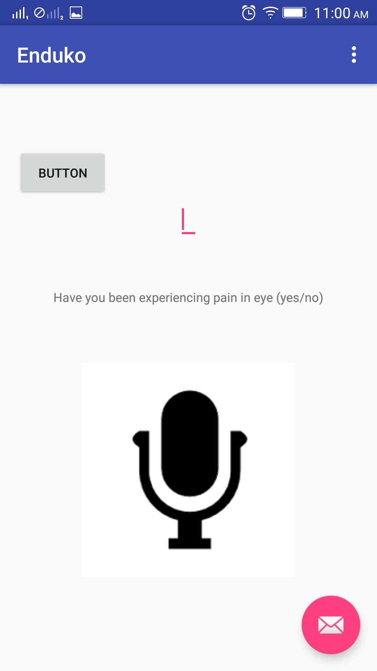

Fig2: Mobile application interrogating the user for further symptoms and conditions

Finally the mobile application prints the disease on device screen. The device also shows the route to the nearest consultant for the disease using google maps API. Using google maps API the current location of user is extracted and is used to suggest, show routes of the nearest medical clinics and hospital who are experts in the specific disease.

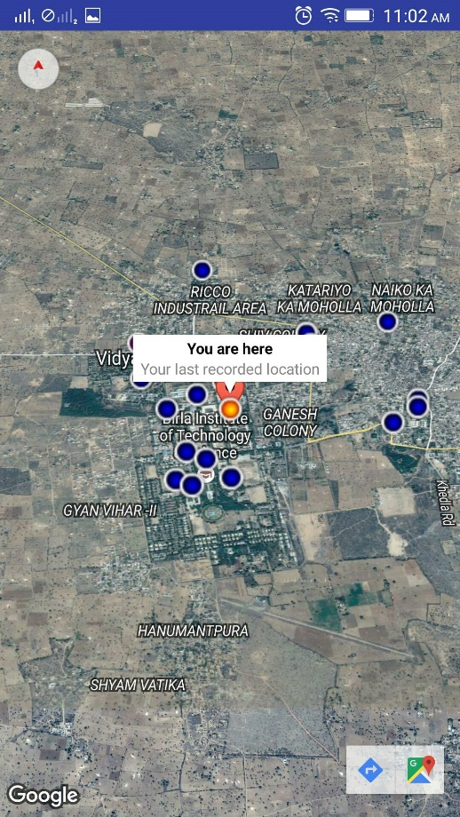

Fig3: Application extracting the current user location would be helpful for routing nearest hospital

1. **CLOUD PROCESSING**

The application is deployed in cloud which could accessed by a user from any place. Deploying the application in cloud makes it more scalable and reduces overhead on the device. Helps in good management of medical databases and history. Our application is developed in Django. Django is a high level web framework using python language. This django application could deployed on a personal server or some cloud storage. We deployed this application on pythonanywhere cloud system. The pythonanywhere platform has a simple configuration settings for deploying and constructing our application in desirable way. The cloud platform receives messages from user i.e. mobile application. It processes those messages and return a message to mobile application. This returned message may be the diagnosed disease or interrogative question to gain more information of patient’s condition. The mobile device just acts as an interactive interface between the server program and user. The server deployed in the cloud does not store state of user conditions at any point of the interaction. The user conditions are stored in a cookie. The cookie helps in storing user symptoms and helps for further processing. The cookie is implemented as symptom array.



Fig4: Messaging between user device and cloud server using a cookie.

This way many users could be handled by the application with less overhead. The cloud also helps in storing of user medical history for deciding the probabilities of a disease. The application could be deployed in any django cloud system when scaled in real world. Each user could be given a login id for identifying the patient.

1. **CONCLUSION**

We have successfully implemented an android application based on cloud server which can provide medical diagnosis from even remote places. We diagnose the disease and then locate the nearest hospitals present. The diagnosis is done by asking questions for more details based on the highest probable disease. We can diagnose diseases from fever, heart attack and some common digestive problems.

The system is tested over many test cases considering the symptoms based in knowledge base for diseases malaria, dengue, typhoid and other diseases. The project is more focused on providing diagnosis for common diseases. To accommodate more diseases we should extract conditions and information about these diseases and add it to the knowledge base.

1. **SCOPE FOR IMPROVEMENT**

In future, the application could also help patients to connect with doctors with the help of hospitals and medical organizations. Advancements in field of human interaction, cognitive systems, sensors, computer vision and natural language processing would improve the research capabilities in medical diagnosis. This could also ensure more marketability for the medical assistance applications.

We can also try to integrate more diagnostic applications like blood pressure and heart beat checker, images to identify the symptoms and many other modules. We have implemented the entire project in English but, for it to be useful for an ordinary person in the rural areas English may not be the suitable language. We can try to implement modules that can recognize their native languages like Hindi, Telugu, Tamil etc. and all the symptoms in that native language also.

The mobile application that we implemented has the map facility. But this facility requires google maps to tag hospitals present in the region. If there are no tags to hospitals in the nearby area then we do not get any hospitals like in the case of Pilani. We can improve this by partnering with an external company that has all the list of hospitals.

1. **REFERENCE**
2. Longo, Fauci, Kasper, Hauser, Jameson, Loscalzo Harrison_'s Principles of Internal Medicine, 18th Edition, McGraw-Hill, 2012, Vol 1.
3. Bird, Steven, Edward Loper and Ewan Klein (2009). Natural Language Processing with Python. O’Reilly Media Inc.
4. S. Moein, S. A. Monadjemi, and P. Moallem (2008). “A Novel Fuzzy-Neural Based Medical,” International Journal of Biologi-cal and Life Sciences, pp. 146-150, 2008
5. A.L.I.C.E. homepage on AIML: Artificial Intelligence Markup Language. [Online]. Available: http://www.alicebot.org/aiml.html
6. Mutual Information homepage on Wikipedia. [Online]. Available: <http://en.wikipedia.org/wiki/Mutual_information>
7. PythonAnywhere website [Online]. Available: <https://www.pythonanywhere.com/>
8. Android Studio home page. [Online] Available : <http://developer.android.com/sdk/index.html>
9. **TESTCASES**

We have shown some of the test cases for sample. We are showing the flow of executing when we do the do following in the application. We can type the following in the application or use the voice recognition button for answering the queries.

**TESTCASE1: Constipation**

*[In the Symptoms box]: I have vomit and strained bowel movement.

*(In the cloud)

*Symptoms Observed are*

*['vomit', 'bowel']*

*[0, 0, 1, 0, 0, 0, 0, 0, 0, 0, 0, 0, 0, 0, 0, 0, 0, 0, 0, 0, 0, 0, 0, 0, 0, 0, 1, 0]*

*[ 3.95821239][ 3.87120101][ 3.95821239][ 0.][ 0.][ 4.9698133]*

*[ 3.95821239][ 3.87120101][ 3.95821239][ 0.][ 0.][ 11.32592096]*

*(Question by app)

Have you been experiencing a small or hard stool. (yes/no)

>>yes

*(In the cloud)

*yes*

*[ 3.95821239][ 3.87120101][ 3.95821239][ 0.][ 0.][ 17.68202862]*

*(Question by app)

Have you been experiencing abdominal pain or stomach ache (yes/no)

>>yes

*(In the cloud)

*yes*

*[ 3.95821239][ 8.03008409][ 8.20410685][ 0.][ 0.][ 22.93952399]*

*(Question by app)

The disease with maximum probability is

constipation

It is a digestion related problem.

**TESTCASE 2: HEART ATTACK**

*[In the Symptoms box]: i have chestpain and sweating.

*(In the cloud)

*Symptoms Observed are*

*['chestpain', 'sweat']*

*[0, 0, 0, 0, 0, 0, 1, 0, 0, 0, 0, 0, 0, 0, 0, 0, 0, 0, 0, 0, 0, 0, 1, 0, 0, 0, 0, 0]*

*[ 0.][ 0.][ 4.24589446][ 4.69787958][ 5.54517744][ 0.]*

*[ 0.][ 0.][ 4.24589446][ 10.49437146][ 5.54517744][ 0.]*

*(Question by app)

Have you been experiencing pain below the breastbone (yes/no)

>>no

*(In the cloud)

*no*

*[ 1.49435915][ 1.40734777][ 5.74025361][ 10.49437146][ 8.33881958][ 2.50596006]*

*(Question by app)

Have you been experiencing pain in the left arm (yes/no)

>>yes

*(In the cloud)

yes

[ 1.49435915][ 1.40734777][ 5.74025361][ 16.29086333][ 8.33881958][ 2.50596006]

*(Question by app)

Have you been experiencing a choking feeling (may feel like heartburn) (yes/no)

>>yes

*(In the cloud)

yes

[ 1.49435915][ 1.40734777][ 5.74025361][ 22.0873552][ 8.33881958][ 2.50596006]

*(Question by app)

Have you been experiencing a Shortness of Breath (yes/no)

>>yes

*(In the cloud)

yes

[ 1.49435915][ 1.40734777][ 5.74025361][ 27.88384708][ 8.33881958][ 2.50596006]

*(Question by app)

Have you been experiencing discomfort (yes/no)

>>yes

*(In the cloud)

yes

[ 1.49435915][ 5.56623085][ 9.98614807][ 32.58172666][ 8.33881958][ 2.50596006]

*(Diagnosis by app)

The disease with maximum probability is

heartattack

It is a heart related problem.